## House or Yard Cleaning Services Design Outline

### Constants

1. The number of rooms that make the size of the house

Small house = 2

Medium house = 4

Large house = 6

1. House cleaning types:

Light

Complete

1. Cleaning types price list based on the number of houses

Small:

Light = 200

Complete = 250

Medium:

Light = 400

Complete = 450

Large:

Light = 600

Complete = 650

1. The types of yard cleaning services

Mowing

Edging

Shrub pruning

1. The square footage of the yard mowing cost = 178
2. The linear footage of the yard’s edges = 102
3. The cost of shrub pruning one shrub = 13
4. The fixed dollar discount for seniors = 200
5. The age at which a person is considered a senior = 65
6. The general types of cleaning

Yard cleaning

House cleaning

1. A defined price list to look up the yard cleaning services

Mowing: 178

Edging: 102

Shrub pruning: 13

### User input

1. The general type of cleaning they require (house/yard)
2. For house cleaning:
   1. The number of rooms in the customer's house.
   2. The type of cleaning they require from the list of; LIGHT or COMPLETE cleaning.
   3. The age of the user
3. For yard cleaning:
   1. The type of yard services the user needs (mowing/edging/shrub pruning)
   2. For the type, enter a unit, that is, square footage for the yard or linear footage of the yard edges of the number of shrubs.
   3. The age of the user

### Program output

1. The cost of cleaning the house if the user wants house cleaning services.
2. The cost of cleaning the yard if the user wants yard cleaning services.
3. User menu prompt if the general type of cleaning is invalid.
4. Error message, if the type of cleaning is not in our catalogue.

### Steps on how to achieve this

1. Prompt the user, for the type of cleaning (house/yard)
2. If the user chooses the house cleaning services
   1. Prompt the user for their input, that is, the number of rooms and the type of cleaning and their age.
   2. Validate that the type of cleaning the user has entered is part of the services we offer in our catalogue (LIGHT and COMPLETE)
      1. If it is not in our catalogue, the program outputs an error message telling them we don’t have the service.
   3. If it is in our catalogue, we check the number of houses the customer has added, to accurately determine the size of their house.
   4. From the house size and the cleaning type, we check out the price list to get the customer's price tag.
   5. From the price tag, we compute the total cost of cleaning the house, by multiplying it by the number of rooms in the house.
   6. If the user is 65 years and above (a senior), calculate the total cost they will pay minus the fixed seniors discount amount.
   7. Output the total cost of cleaning the house to the customer.
3. If the user chooses the yard cleaning services
   1. Prompt the user for their input, that is, the type of yard cleaning they need, the unit of work required and their age.
   2. Validate that the type of yard cleaning the user has entered is part of the services we offer in our catalogue
      1. If it is not in our catalogue, the program outputs an error message telling them we don’t have the service.
   3. Check the price list of the type of yard cleaning service the user has requested and multiply that by the unit number the user has added to get the total yard cleaning cost.
   4. If the user is 65 years and above (a senior), calculate the total cost they will pay minus the fixed seniors discount amount.
   5. Output the total cost of cleaning the house to the customer.

### 

### Test Cases

| **Test Case** | **User Input** | **Cost for Light Cleaning** | **Cost for Complete Cleaning** | **Total Yard Service Cost** |
| --- | --- | --- | --- | --- |
| Light and complete cleaning for a house with 3 rooms | Type of cleaning = house  No. of rooms = 3  Age = 45 | $1200 | $1350 | - |
| Light and complete cleaning for a house with 3 rooms for seniors | Type of cleaning = house  No. of rooms = 3  Age = 66 | $1000 | $1150 | - |
| Mowing yard services | Type of cleaning = yard  Type of yard service = mowing Unit = 10 sq footage  Age = 45 | - | - | $1780 |
| Mowing yard services | Type of cleaning = yard  Type of yard service = mowing Unit = 10 sq footage  Age = 66 | - | - | $1580 |
| Edging yard services | Type of cleaning = yard  Type of yard service = edging Unit = 5 linear footage  Age = 20 | - | - | $510 |
| Edging yard services for seniors | Type of cleaning = yard  Type of yard service = edging Unit = 5 linear footage  Age = 76 | - | - | $310 |
| Shrub Pruning yard services | Type of cleaning = yard  Type of yard service = prunning Unit = 20 shrubs  Age = 39 | - | - | $260 |
| Shrub Pruning yard services for seniors | Type of cleaning = yard  Type of yard service = prunning Unit = 20 shrubs  Age = 90 | - | - | $60 |
| Invalid general cleaning type | Type of cleaning = invalid | - | - | - |
| Invalid house cleaning service | Type of cleaning = house  Type of house cleaning = invalid | - | - | - |
| Invalid yard cleaning service | Type of cleaning = yard  Type of yard service = invalid Unit = 10  Age = 34 | - | - | - |

### 

### Screenshots

#### Light and complete cleaning for a house with 2 rooms

#### 

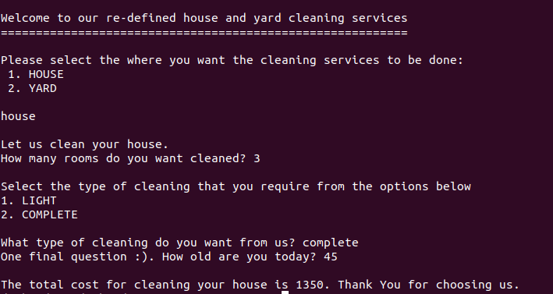

#### Light and complete cleaning for a house with 2 rooms for seniors

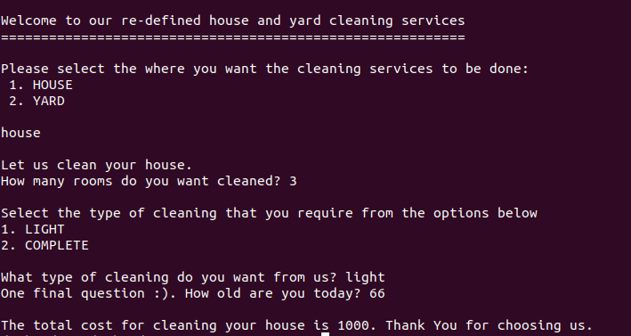

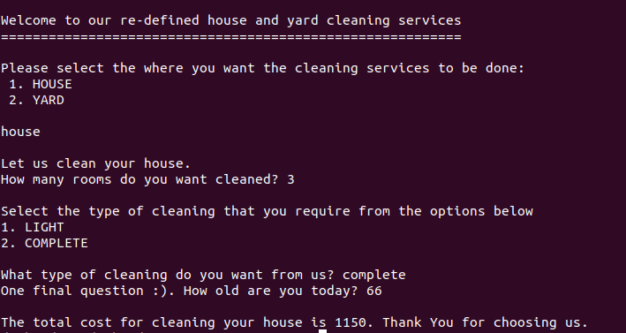

#### 

#### Mowing Yard Services

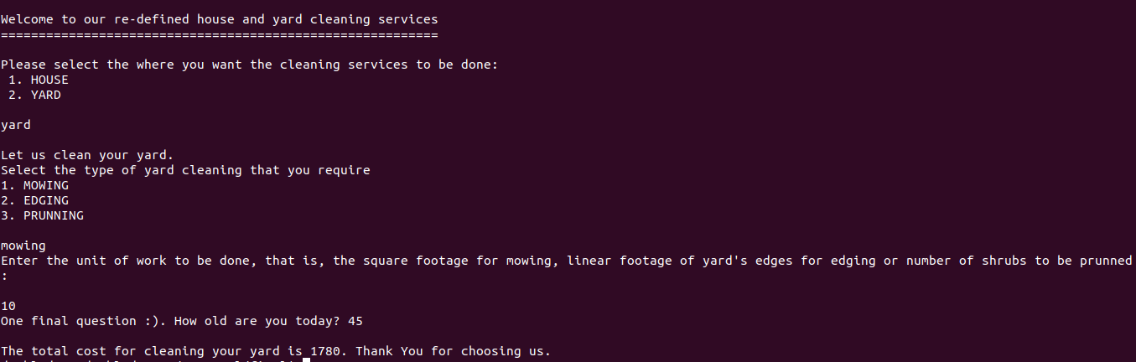

#### Mowing Yard Services for Seniors

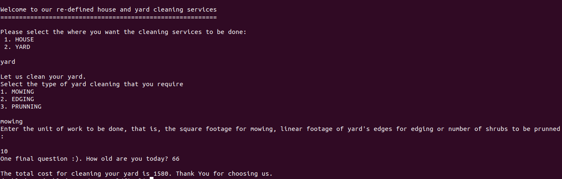

#### Edging Yard Services

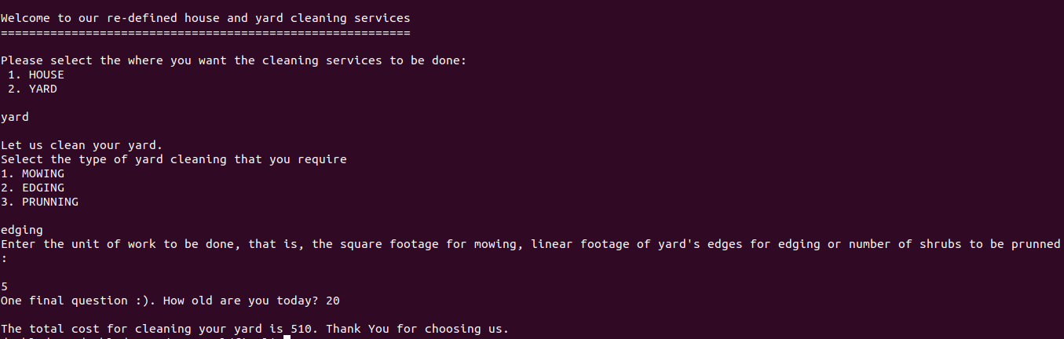

#### Edging Yard Services for Seniors

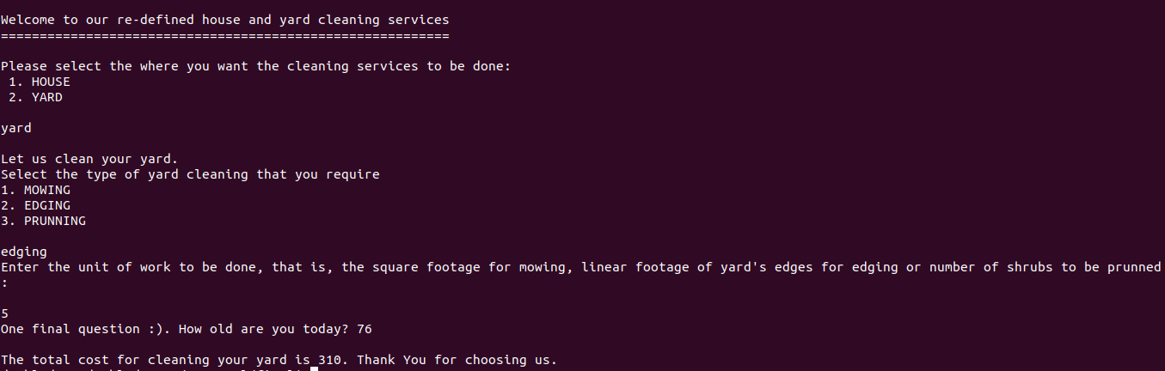

#### Shrub Pruning yard services for seniors

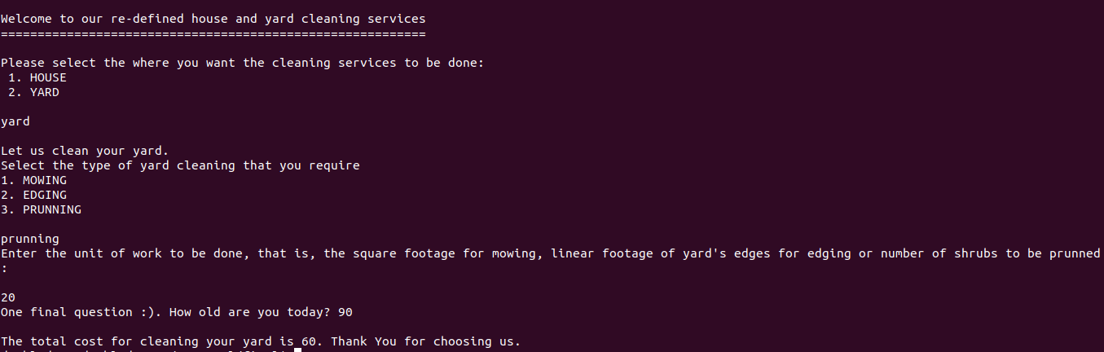

#### Shrub Pruning yard services

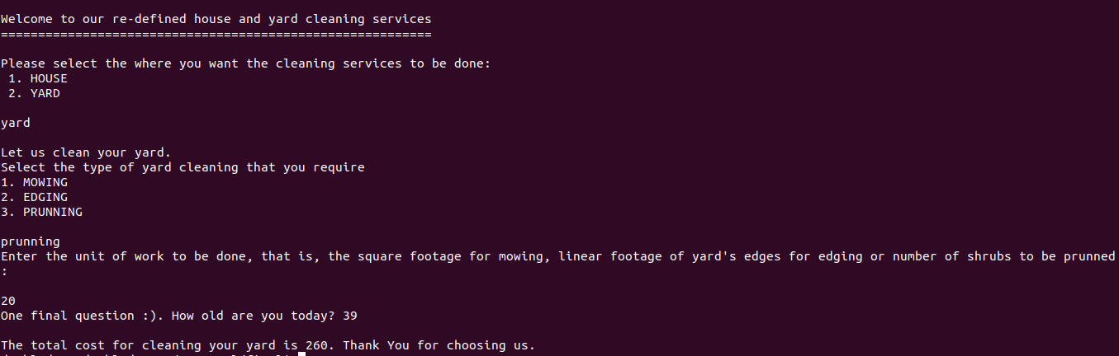

#### Invalid general cleaning type

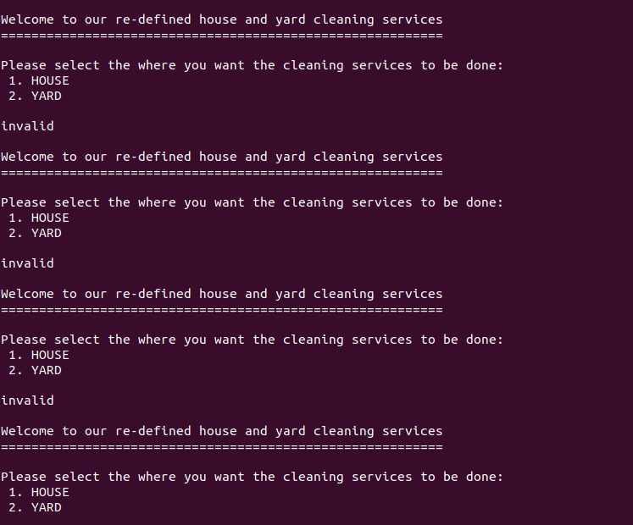

#### Invalid house cleaning service

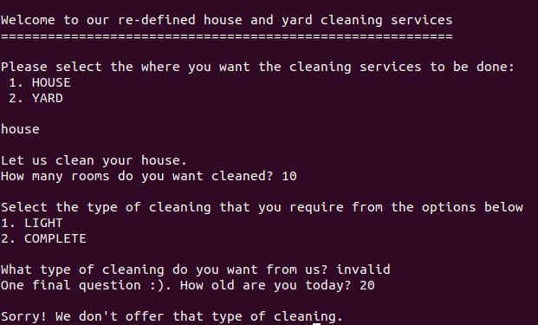

#### Invalid Yard cleaning service

